

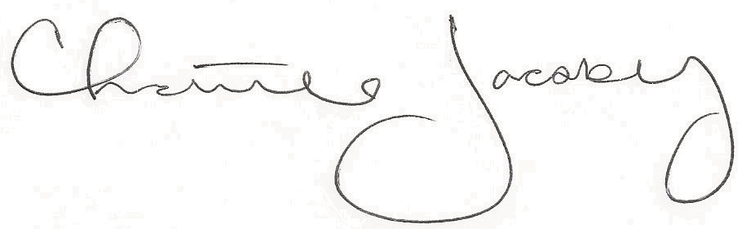
Christine Jacoby
Freese and Nichols
SAME Fort Worth Post Vice President
Speaker:
Carl Tucker, Deputy Logistics Branch Chief
FEMA Region 6
Topic:
FEMA Contracting Opportunities and Methodology
12:00 p.m. at the Fort Worth Petroleum Club
777 Main St., Fort Worth, TX

1.0 PDH credit
Certificate of Completion for
Professional Development Hours (PDH’s)
November 8, 2023
This letter serves as verification that
attended the technical seminar.

