
Speakers:
Cecilia Salvans, AICP
Rives Taylor, FAIA, LEED Fellow, NCARB
Jared Huffman
David Mass
Tammy Huddleston
Nicole Wiesner, PE & Patrick Miles, PE
Topic:
Annual Resiliency Workshop

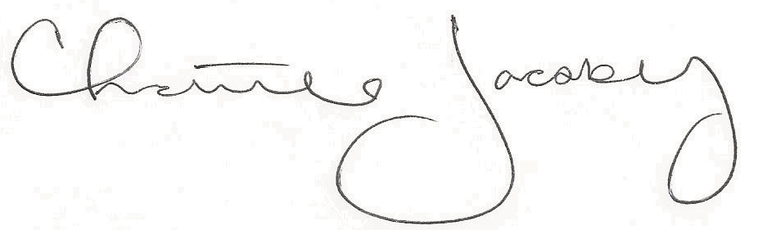
Christine Jacoby
Freese and Nichols
SAME Fort Worth Post Vice President
8:30 p.m. at the Fort Worth Petroleum Club
777 Main St., Fort Worth, TX

4.0 PDH credit
Certificate of Completion for
Professional Development Hours (PDH’s)
August 9, 2023
This letter serves as verification that
attended the aforementioned technical seminar.

