

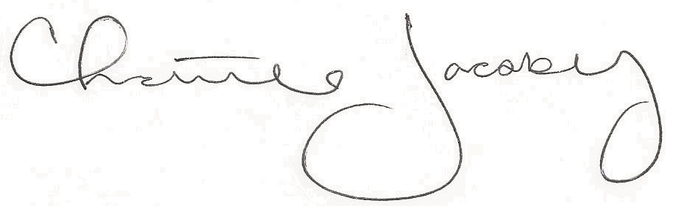
Christine Jacoby
Freese and Nichols
SAME Fort Worth Post Vice President
Speaker:
Debra Castens, P.E.,
Deputy Branch Chief in Professional Services Branch of USACE Fort Worth District

Topic:
Task Order Requirement Notice (TORN) Process

12:00 p.m. at the Fort Worth Petroleum Club
777 Main St., Fort Worth, TX

0.5 PDH credit
Certificate of Completion for
Professional Development Hours (PDH’s)
January 4, 2023
This letter serves as verification that
attended the aforementioned technical seminar.

