

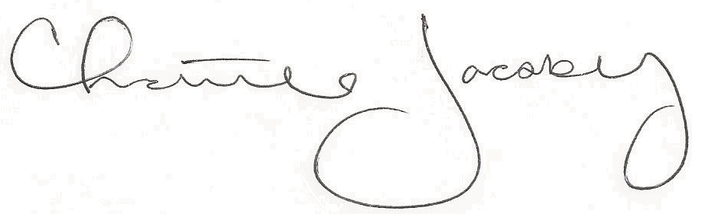
Christine Jacoby
Freese and Nichols
SAME Fort Worth Post Vice President
Speaker:
Judge Tim O’Hare for Tarrant County
Topic:
Tarrant County Priorities

12:00 p.m. at the Fort Worth Petroleum Club
777 Main St., Fort Worth, TX

0.5 PDH credit
Certificate of Completion for
Professional Development Hours (PDH’s)
May 10, 2023
This letter serves as verification that
attended the aforementioned technical seminar.

