

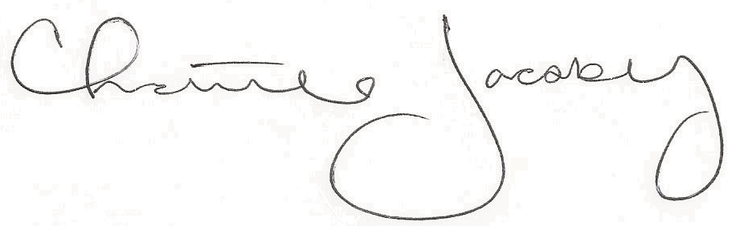
Christine Jacoby
Freese and Nichols
SAME Fort Worth Post Vice President
Speaker:
Robert P. Morris, Jr., P.E., PMP
Deputy District Engineer for Programs
& Project Management of USACE Fort Worth District

Topic:
Fort Worth Engineer District Projects, Program, and Business Opportunities

The (CMMC)
12:00 p.m. at the Fort Worth Petroleum Club
777 Main St., Fort Worth, TX

0.5 PDH credit
Certificate of Completion for
Professional Development Hours (PDH’s)
February 9, 2023
This letter serves as verification that
attended the aforementioned technical seminar.

