

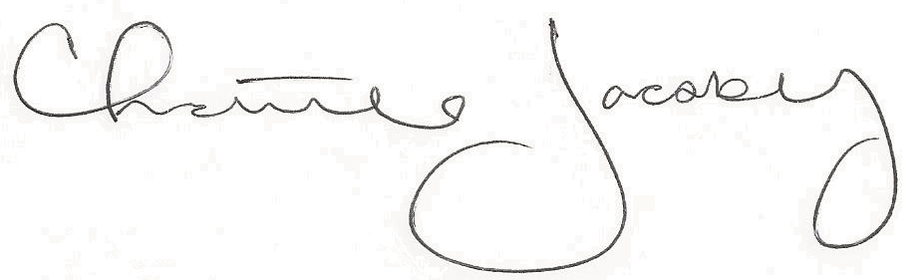
Christine Jacoby
Freese and Nichols
SAME Fort Worth Post Vice President
Speaker:
Angelina Calloway, Attorney
Topic:
GSA Contracting 101

12:00 p.m. at the Fort Worth Petroleum Club
777 Main St., Fort Worth, TX

0.5 PDH credit
Certificate of Completion for
Professional Development Hours (PDH’s)
March 1, 2023
This letter serves as verification that
attended the aforementioned technical seminar.

